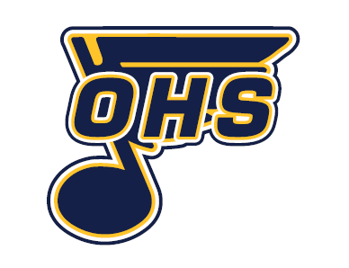

OHS Varsity Boys Hockey – Head Coach Position (2026–2027 Season)
Oromocto High School is seeking applications for the position of Varsity Boys Hockey Head Coach for the 2026–2027 season.
Interested applicants are asked to submit a coaching résumé and letter of interest to amy.mackinnon@nbed.nb.ca.
The letter of interest should include:
- Full name and contact information
- Vision for the program
- Relevant coaching experience
Please note that the successful candidate will be required to provide a current Criminal Record Check and complete all requirements related to Policy 701.
Applications will be accepted until May 27th, 2026.
All applications will be reviewed by the school extracurricular committee. Candidates may be invited to participate in an interview process.
Thank you to all applicants for your interest in OHS Athletics.

Amy MacKinnon
Athletics Director
Oromocto High School

