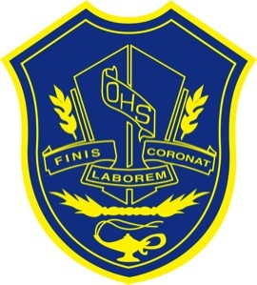

Oromocto High School Extra-curricular Activities

2023 - 2024

|  |
| --- |
| Activity |
| Academic Excellence & Merit |
| Activity Expo  (September 8, 2023) |
| Ambassadors |
| ARROW Tour  (University, Colleges, Trade Schools) |
| Assemblies (various) throughout year |
| Athletics and Athletic Banquet |
| Auto Club/Racing Club  **(in the works)** |
| Backpack Program (providing backpacks of food for students with food insecurity) |
| Beautification/Property Clean Up |
| Best Buddies |
| BIPOC committee |
| Blood Donor Clinics |
| Breakfast for Learning |
| Chess Club |
| Disability Walk |
| Drama |
| Dungeons & Dragons |
| First Aid Service Team |
| First Nations Cultural Week |
| French Cultural Celebrations |
| French for the Future |
| French Oratorical Competition |
| FI Assembly |
| GSA |
| Grad Class |
| Grad Class Banquet |
| Grad Class Prom |
| Grade 8 Orientation |
| Grade 8 to 9 Transition to HS |
| Grade 9 Orientation |
| Graduation |
| Guitar Club |
| Halloween Celebrations |
| International Student Program /International Club |
| Intramurals |
| Kindness Group |
| Letter “O” Activity Awards |
| NBTA Reps |
| New Boots Club- females in trades |
| OHS Concert Band |
| OHS Cyber Titans/Chatterhigh |
| Peer Tutors |
| Reach for the Top |
| Recycling |
| Relay for Life |
| Robotics Engineering Team |
| Safe Grad |
| Scholarships |
| School Clothing |
| School Grad Trip |
| School social media |
| Student Council (SRC) |
| Students of the Month |
| Tech Crew |
| Terry Fox Walk |
| Turnaround Achievement Awards |
| Unified Basketball |
| Writing Club |
| Yearbook |
| Yoga Club **(in the works)** |